There is confidence that the “El Tumbador” case will break the paradigm of impunity in Honduras
defensores – Nov. 17, 2019
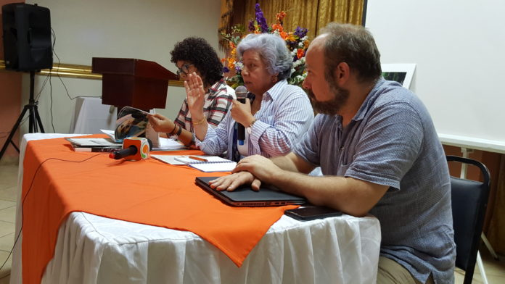 Juana Esquivel, Bertha Oliva and Lucas Valderas
Tocoa, Colón. - With sadness and tears, but with the hope of achieving justice at the international level, the Informational Workshop in Commemoration of the Tumbador case was held on November 15th, nine years after the massacre of five campesinos from the Guadalupe Carney community, affiliated with the Campesino Movement of the Aguán (MCA) in the municipality of Trujillo, department of Colón.
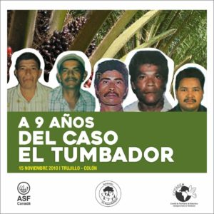
The event which included a press conference, an exhibition of commemorative photos and the presentation of a documentary on the Tumbador, was convened by Lawyers without Borders-Canada, the San Alonso Rodríguez Foundation (FSAR) and the Committee of Families of the Detained and Disappeared in Honduras (COFADEH), organizations representing the case in the Inter American System of Human Rights. Campesinos and campesinas from the Guadalupe Carney community, representatives for the Union of National Agrarian Institute Workers (Sitraina), Coordinator of Popular Organizations of the Aguán (COPA), human rights defenders, journalists and social communicators, the widows of the murdered campesinos and survivors of the massacre attended the workshop.
On November 15, 2010, in the midst of an enormous deployment of police and military in the african palm plantation known as “El Tumbador”, in Trujillo, Colón, security guards for the Orión Company, providing security for the Dinant Corporation, (which sought to claim possession of the plantation) ambushed and killed the campesinos as they prepared to work the land.
The murdered campesinos were identified as Raúl Castillo, Ignacio Reyes, Teodoro Acosta, Ciriaco Cárcamo and José Luis Sauceda Pastrana.
The Director of the San Alonso Rodríguez Foundation (FSAR), Juana Esquivel, said that the Investigative Unit for Violent Murders in the Aguán (UNVIBA) established in 2014 by the Public Ministry (MP), has provided no answers in response to demands for clarification of what occurred.
“There is no response to this demand for justice by the campesino organizations, the families, the social organizations that have been constantly denouncing the impunity in which over 140 murders related to the agrarian conflict here in the Bajo Aguán remain”, stated Esquivel.
There are public denunciations from the families of the victims in which they say that the last time they went to this office (UNVIBA) to demand justice, they were evicted. “It is a farce that this special unit is investigating the deaths of campesinos in the Aguán because there are no results from the investigations, particularly those cases directly involving the companies, like the case of el Tumbador, in which the Dinant Corporation is involved”, denounced the FSAR Director.
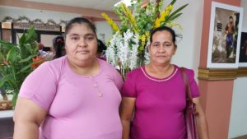María Concepción Membreño (widow of Teodoro Acosta) and Marta Julia López (widow of Ciriaco de Jesús Muñoz)
The General Coordinator of COFADEH, Bertha Oliva said that the as the legal representative for the victims, the Committee has accompanied and demanded justice in this case for 9 years.
“We want this effort, that the 3 organizations represented here today, COFADEH, the San Alonso Rodríguez Foundation (FSAR) and Lawyers without Borders Canada (ASFC) have embraced, to be full of solidarity to work with all the energy possible to rescue historic memory” said Oliva.
We know that the perpetrators are determined to erase memory because memory is the defense of the people, and the soul of the families.
We should honor not only the memory of the campesinos that are no longer here, who struggled for a piece of land, but also the widows and survivors of the massacre that occurred 9 years ago.
“With this public event, we raise hope to continue working. One year ago we presented the case of El Tumbador in the Inter American Commission on Human Rights (IACHR) with the facts and results that we have obtained” announced Oliva.
Oliva said that they always work with the families in the cases, confronting state terrorism and challenging human perversity.
“We want to establish a case that breaks the paradigms of impunity in Honduras, this is our task, and to reconstruct memory and raise the self-esteem of victims and their family members” explained the coordinator of COFADEH.
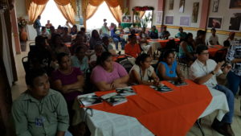Bertha Oliva emphasized that the massacre in Tumbador was not only a criminal attack against 5 campesinos, but an aggression against an entire people.
The attorney Lucas Valderas, representative and coordinator of Lawyers without Borders – Canada (ASFC) in Honduras, told www.defensoresenlinea.com that ASFC has a strong commitment to improve access to justice for victims of human rights violations, in particular those in situations of vulnerability. ASFC achieves this objective by working with partners like COFADEH, providing direct support in the representation of these people.
“That is why ASFC has collaborated with COFADEH since 2015, with volunteer lawyers who are experts in litigation of human rights cases at the inter-american and international levels, to promote emblematic cases such as the case of El Tumbador”, affirmed Valderas.
During these years, ASFC, has monitored the human rights situation in the north of the country, and is knowledgeable about the attacks and murders of campesinos in which private security agents are involved
“In this context of human rights violations and impunity, the Committee of Families of the Detained and Disappeared in Honduras (COFADEH), the San Alonso Rodríguez Foundation (FSAR) and Lawyers Without Borders (ASFC) have joined forces to present a petition before the Inter American Commission on Human Rights (IACHR), for the massacre of 5 campesinos in the plantation of El Tumbador”, he explained.
This petition is based on the lack of results from the investigation, the failure to identify and bring to justice those responsible and the lack of effort to assure adequate reparation for victims and survivors, explained Valderas.
ASFC stated that “the petitioning organizations want to demonstrate that the State of Honduras is responsible in the framework of its international human rights obligations, for the violation of the right to life of the victims: Teodoro Acosta, Raúl Castillo, Ignacio Reyes, Ciriaco de Jesús Muñoz Aguilar and José Luis Sauceda”.
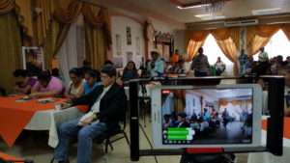
COFADEH transmitted via Facebook-Live
We also intend to demonstrate before the Inter-American system that the state of Honduras failed to guarantee the right to humane treatment when the victims were violently repressed in a peaceful protest of campesinos resulting in the death of five people, the lack of investigation into the attempted murders of Francisco Celedonio Ramírez Licona, Pedro Deras Olivera, Marvin Jerónimo Méndez Leiva, Abraham Martínez Ventura, victims of serious injury by firearms and the detention and cruel treatment of Apolinaria Urrea Sagastume, Lilian Elizabeth Urrea Sagastume, Jesús Regalado and María Arcadia Ramos Santos.
The petitioning organizations also stated that the rights to judicial guarantees and to effective legal protection were violated, the right to honor, freedom of expression, the right to assembly and freedom of association, rights to private property and social development, the right to equality before the law, the right to family protection and the rights of children and the right to humane treatment of the family members of the victims.
Representing the widows, Marta Julia López, wife of Ciriaco de Jesús Muñóz, spoke to www.defensoresenlinea.com expressing that “with help from you and from God, we hope to achieve justice”.
Marta Julia said that during these 9 years, she and her four children have experienced “cruel times”, but they have grown and together with the other widows, they have been able to strengthen themselves to continue on.
- http://defensoresenlinea.com/existe-confianza-que-el-caso-el-tumbador-rompa-paradigmas-de-impunidad-en-honduras/

